IMU recycling day in Kalasatama on Saturday 2.10.2021 from 10am to 3pm

IMU recycling day in Kalasatama will be held on Saturday 2.10.2021 from 10am to 3pm. Electrical waste, scrap metal and large waste items will be collected at two collection points.

There will be youth from the 4H-organisation to help with the sorting. This waste collection is only for residents using the pipeline-based waste collection system. Please present your IMU-key at the collection point.

The collection points are located on the map:

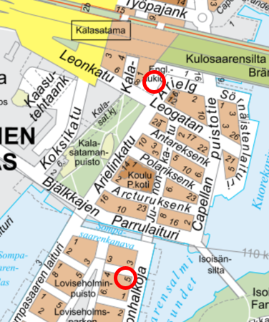

Collection point Englantilaisaukio
is located in a field between Redi shopping center and Arielinkatu

Collection point Sompasaari
is located in a junction of Aallonhalkoja 5 and Flöitti Dianan kuja

PLEASE REMEMBER TO KEEP SAFETY DISTANCE FOR OTHER RECYCLERS!

YOU CAN BRING:
LARGE MIXED WASTE:
carpets, mattresses, buckets, folders, small furniture etc.

ELECTRICAL AND ELECTRONIC WASTE:
television, home appliance, mobile phone, computer, small appliances, power tools etc.

SCRAP METAL:
bicycle, prams, grills, pots, tools, metal containers, metal furniture etc.
DO NOT BRING:
HAZARDOUS WASTE:
- paints, solvents, liquid batteries
  - HSY hazardous waste container
- waste containing asbestos
  - HSY Sortti station (Ämmässuontie 8, 02820 Espoo)
- pressure treated timber
  - HSY Sortti station
- medicines, syringes Pharmacy
- explosives or guns Police
- batteries Grocery stores

___________________________________________________________________________

